Task 1: Selecting Your Client and Planning Your Website Design
Name: Francisca Falaise
Date: March 23, 2026
Client’s Name: ABC Fitness Studio
Wireframes
The wireframes below present the required eight layouts for the ABC Fitness Studio website: four mobile wireframes and four desktop wireframes. Each version includes the required Homepage, Gallery page, About Us page, and custom page, while maintaining a consistent header, navigation structure, and footer.
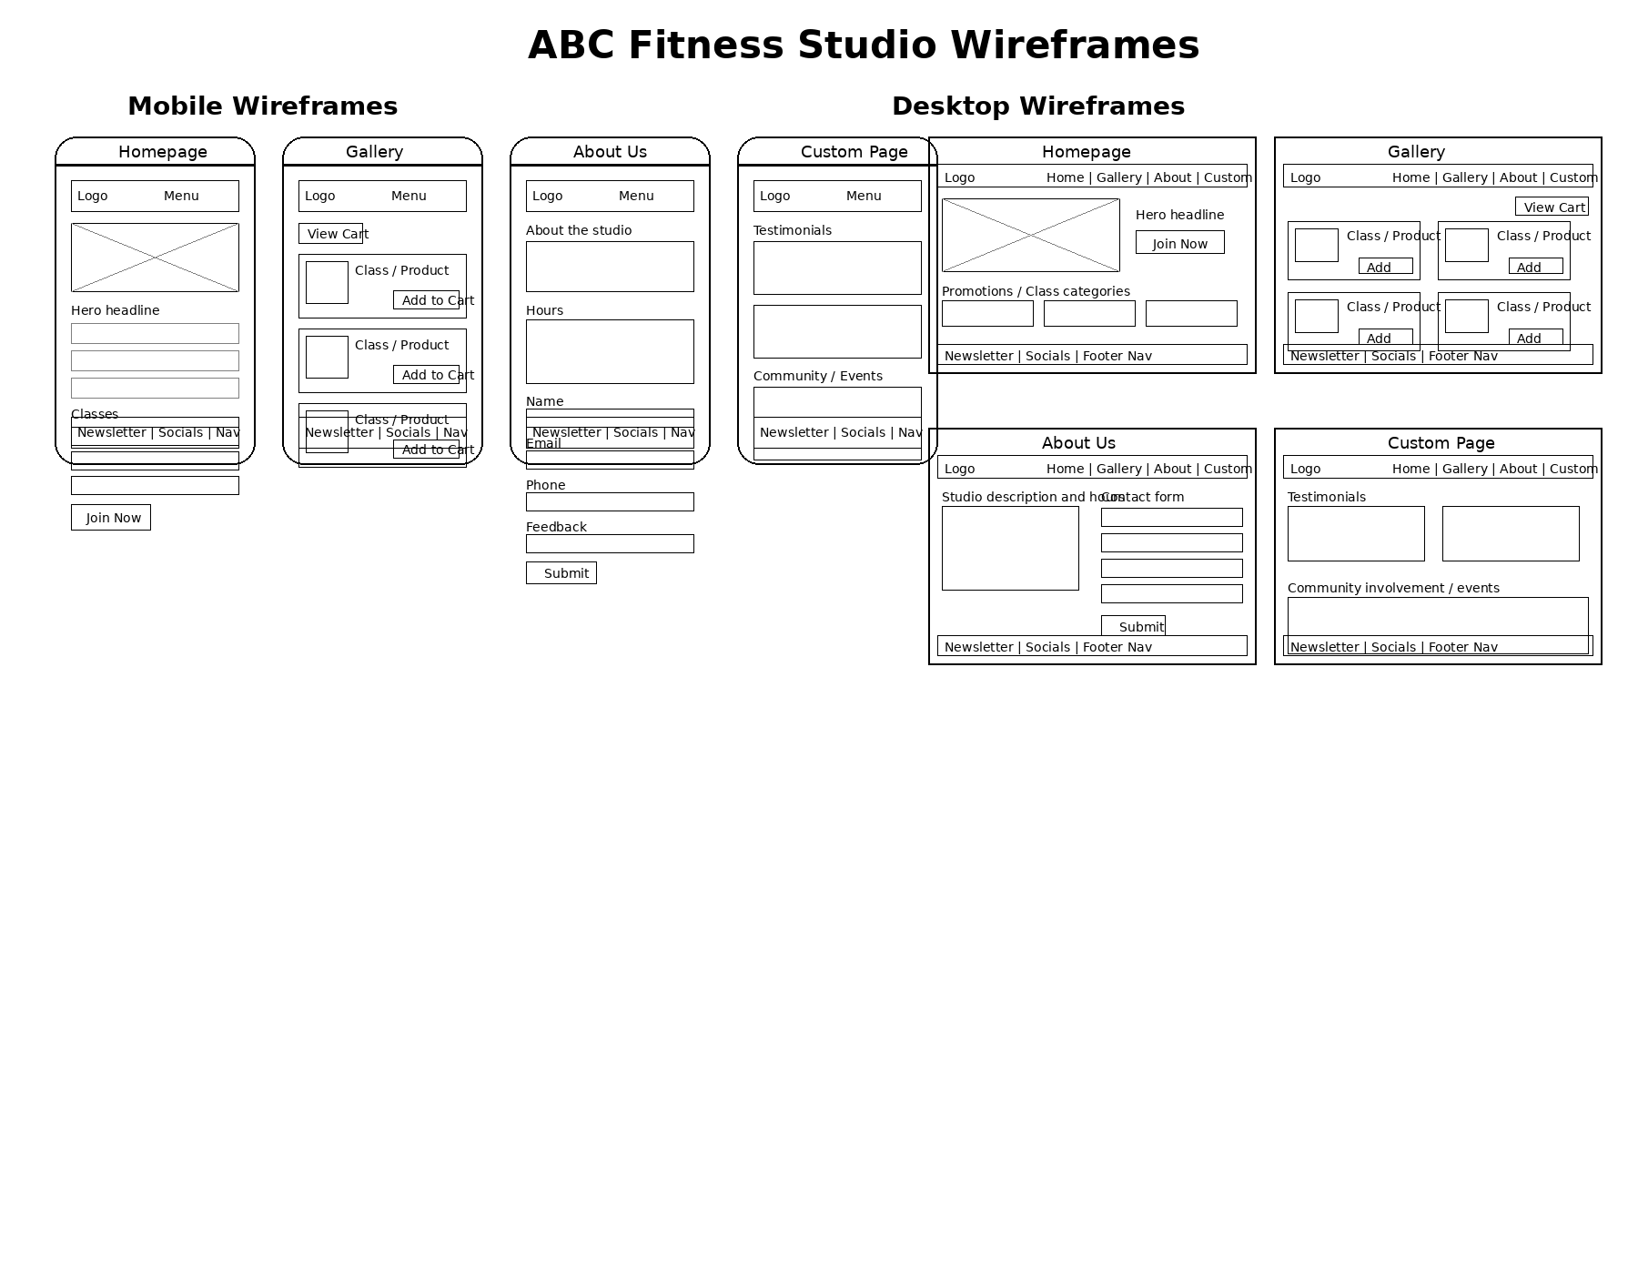

Color Palette Selection
Color Palette 2
Color Palette Analysis
The color palette was chosen because it creates a balance between energy and comfort, which fits a fitness environment. The mix of darker and lighter tones makes the website feel modern while still being easy to look at for long periods of time. It also helps important sections stand out without overwhelming the user.
Logo Selection
Nourish Navy Logo (Color Palette 2)
Logo Selection Analysis
The Nourish Navy logo fits well with the overall theme of the website and helps create a strong first impression. It gives off a clean and professional look while still feeling active and relevant to fitness. Using a logo that matches the color palette keeps the design consistent across all pages.
Font Color Selection
Font Color 1 (Detritus Green – #00231C)
Font Color Analysis
The font color was selected because it is easy to read against the background and does not strain the eyes. Instead of using pure black, this color feels a bit softer while still being clear. This makes it easier for users to read information quickly, especially on mobile devices.
Typography Selection
Typography Option 2
Typography Analysis
The typography uses simple fonts like Arial and Calibri, which are commonly used on websites. These fonts are easy to read and look clean on both mobile and desktop screens. Keeping the font simple helps users focus on the content instead of being distracted by the design.

